### NOTTINGHAM TRENT UNIVERSITY NOTTINGHAMSHIRE

### CLIFTON CAMPUS NG1 1DG



**“SMART PARKING SYSTEM”**

**MINI PROJECT – EMBEEDED SYSTEMS**

Submitted in Partial Fulfilment for the Award of

**MASTERS OF SCIENCE**

in

**ELECTRONICS**

By

**SHAIK SHAHANAZ**

**ID: N0905255**

TABLE OF CONTENTS

|  |  |
| --- | --- |
| TABLE OF FIGURES | 3 |
| TABLE OF FLOWCHART | 3 |
| INTRODUCTION | 4 |
| BACKGROUNG INFORMATION | 4 |
| 3.1 METHODOLOGY | 5 |
| HARDWARE COMPONENETS | 5 |
| 3.1.1 ARDIUNO BOARD | 5 |
| 3.1.2 LCD SCREEN | 5 |
| 3.1.3 IR- SENSOR GP2D12 | 6 |
| 3.1.4 SERVO MOTOR | 6 |
| 3.1.5 LED LIGHT | 7 |
| 3.1.6 BUZZER | 7 |
| 3.2 SOFTWARE COMPONENET | 8 |
| THE DESIGN OF THE SMART PARKING SYSTEM | 9 |
| 4.1 THE WORKING PROCEDURE OF THE PROTOTYPE | 10 |
| 4.2 CIRCUIT DIAGRAM | 12 |
| 4.3 IMPLEMENTATION OF THE PROTOTYPE | 12 |
| 4.4 ADVANTAGES | 13 |
| CONCLUSION | 14 |
| FUTURE WORK | 14 |
| BIBLOGRAPHY | 14 |
|  |  |
|  |  |
|  |  |

TABLE OF FIGURES

Figure 1- Arduino Uno 5

Figure 2-16X2 LCD Display 6

Figure 3- Gp2d12 7

Figure 4- pinout connection details of GP2D12 7

Figure 5- Block Diagram 7

Figure 6- Servo Motor 8

Figure 7- Green, Red, Blue led light 8

Figure 8- Buzzer 8

Figure 9- The circuit diagram of prototype 12

Figure 10- Demo-1 12

Figure 11–Demo-2 13

Figure 12 Output results of the distance measuring sensor 13

**TABLE OF FLOWCHARTS**

Flowchart 1- For working process of prototype 8

Flowchart 2- LCD operation 9

Flowchart 3- Describes the operation in parking slot 10

**SMART PARKING SYSTEM**

1. **INTRODUCTION**

Vehicles became one of the most essential needs after food, shelter and clothes. With the growing population the buyers of vehicles it may be two-wheeler or four-wheeler vehicles are also increasing in large number and this lead in the congestion at roads, parking places and sometimes it appears difficult in finding the slots/place to park the vehicle. Various measures are taken to reduce the congestion of vehicles on road like by implementing the Parking management system so that no vehicles are parked at the roadside but only on allotted parking areas. But parking the vehicle in allocated slot requires time, effort to detect the spot and manual guidance.

Smart Parking System overcomes the difficulties and challenges which arises in the human guided traditional parking system. Smart Parking system provides the solution for the easy detection of the parking slot by reducing the time, fuel, manual effort and easy traffic management.

In this project report illustrates the solution to parking system not only to the public area parking but also to the individual use such as in-home parking.

**2. BACKGROUND INFORMATION**

In present situations when we go to malls or hospitals, amusement park, etc. public places we always search for the parking slot and in those crowded places searching the slot for parking is not an easy task as it takes time and fuel waste. While parking sometimes from car it is difficult to identify the small obstacle or small divider ahead in front of the car and gets collided to it. So, these types of problems can be overcome by using SMART PARKING SYSTEM.

Our system is an Arduino based Smart Parking System, which uses Sharp Infra – red sensor which not only detects the empty parking slot but also detects the distance of the vehicle under its range and alerts the driver by assisting the vehicle to be parked precisely in the slot and also alerts of being collided with the wall.

In this model of Parking system, the availability of the slot can be easily identified by LCD display which gives the information of the availability of parking slot so that the user saves its time and fuel by not searching in that area where parking slots are all occupied. The main aim of the project is to develop a system which is cost effective and delivers high performance with multiple features and can be used in various applications that is not only at public places but also at homes. In home parking system this system detects the coming vehicle to the garage and opens the door automatically and if there are more than one parking slot available then we can easily identify by color light indication.

**3. METHODOLOGY**

As per the research study report, with the increase in the per head vehicle number about 40% of the roads are occupied only for parking vehicles (Parking Problems in India and Their Solutions, 2020). In this scenario the government officials are working best to solve the issues by many methods by allocating the parking space but still problem not end here as the availability of the parking slot is still unknown.

The approach concept of the development of this project depends on:

1. To know the availability of the parking slots before entering.
2. Easy identification of the availability of the slots by color LED indications.
3. Alert by alarm and sound indication while parking into slot before gets collide to wall as for safety.
4. Automated opening of the opening of the gate while as the car is approaching near the slot.
5. If the system is used in home, then automatically the shutters can be open as the vehicle approaches the garage.

*3.1 HARDWARE COMPONENTS*

The hardware components which were used in this project are:

3.1.1ARDUINOBOARD - *Arduino Uno plays a vital part in our project. It contains the software data of the project in it.* It operates with an ATmega328 controller. This type has 14 digital ports (I / O), 6 of which can be used for ports to control the "PWM Outputs", the most important feature of this type is the control chip" ATmega328" is not fixed in the board, but installed on the holder of the integrated circuit" IC. This feature makes it helpful to restore work on the board if burned the slide while working on your project by mistake, simply changing the slide The ATmega328 controller to the same model.

Figure - Arduino Uno 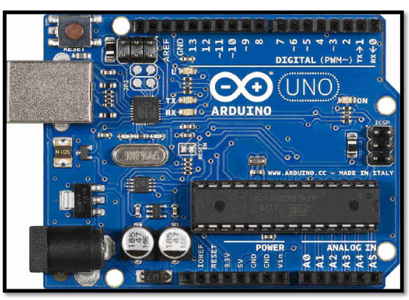

3.1.2LCD Screen - Liquid Crystal Display is a flat panel display.it is an electronically modulated optical device which uses the light modulating properties of liquid crystals. Here liquid crystals do not emit light directly, instead using a backlight or reflector to produce images in colour or monochrome. LCDs are available to display arbitrary or fixed images with low information content, which can be displayed or hidden. (16x2 LCD Module: Pinout, Diagrams, Description & Datasheet, 2020)

Figure -16X2 LCD Display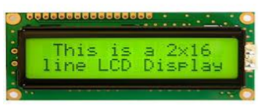

The connection of the LCD is based on following:

|  |  |  |
| --- | --- | --- |
| Serial No. | Function | Name |
| 1. | Ground(0V) | Ground |
| 2. | Power Supply (4.7-5V) | Vcc |
| 3. | Contrast Adjustment (through a variable register) | Vee |
| 4. | Selects data register when high; Selects command register when low | Register Select |
| 5. | Writes to register when low; Reads from register when high | Read/Write |
| 6. | Sends data to data pins when a high to low pulse is given | Enable |
| 7. | Data Pin | DB0 |
| 8. | Data Pin | DB1 |
| 9. | Data Pin | DB2 |
| 10. | Data Pin | DB3 |
| 11. | Data Pin | DB4 |
| 12. | Data Pin | DB5 |
| 13. | Data Pin | DB6 |
| 14. | Data Pin | DB7 |
| 15. | Blacklight VCC(5V) | Led+ |
| 16. | backlight Ground(0V) | Led- |

Table - LCD Pin description

(16x2 LCD Module: Pinout, Diagrams, Description & Datasheet, 2020)

In this project LCD displays the information for the availability of the parking slots and occupied slots.

3.1.3IR-SENSOR - In this project we are going to use Sharp GP2D12 sensor and an Arduino Uno to measure the distance between the sensor and an object. GP2D12 SHARP distance sensor (Weingarten and Elster, 2004) distance measuring sensors from Sharp utilising infrared emitters and photodetectors with integrated signal processing circuitry. The devices are available with either analogue or switched (digital) outputs and include both fixed and variable distance sensors (GP2D12 Sharp, 2020) suitable for number of precise measurement applications.

Figure Gp2d12 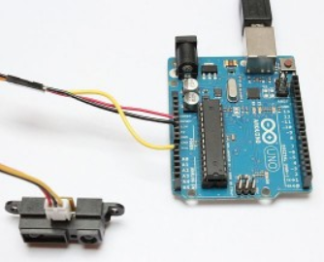

*FEATURES*

* + Analog output
  + Effective Range: 10 to 80 cm
  + LED pulse cycle duration: 32 ms
  + Typical response time: 39 ms
  + Typical start up delay: 44 ms
  + Average current consumption: 33 mA
  + Detection area diameter @ 80 cm: 6 cm

|  |  |
| --- | --- |
|  |  |

Figure pinout connection details of GP2D12 Figure - Block Diagram

In this project this sensor used for following operations-

1. Detection of the vehicle in the slot. (2020)
2. Distance measurement of the vehicle.
3. Distance measurement of the vehicle from the wall in the slot.

The calculation of the distance in terms of cm by GP2D12 sensor is given by 6787.0 / (V- 3.0)) - 4.0 cm. Based on the values obtained from the sharp IR sensor the LED lights, LCD, buzzer and servomotor will operate. So, this is the main sensor of this project.

3.1.4 SERVO MOTOR - The servo engine is a motor that comes with a Gear gearbox and Shaft transmission that gives a motion greater torque and greater precision. This engine can rotate 180 degrees and in some types 360 degrees. The servomotor is internally made up of a "mostly microcontroller" control circuit. (Servo Motor Basics, Working Principle & Theory, 2020) When the engine gives pulses at a certain time constant, the engine rotates to the angle according to that time constant. By operating servo motor here, we can control the movement of the gate or shutter.

Figure - Servo Motor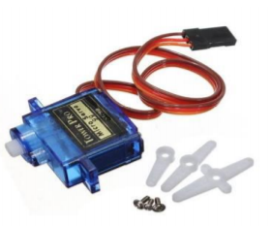

3.1.5 LED LIGHTS – Light Emitting Diode operates on the values obtained from the IR sensor and depending on these values the corresponding lights that is red, blue and green light will glow.

Figure - Green, Red, Blue led light 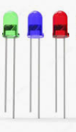

RED LED - indicates that the slot is occupied,

BLUE LED - indicates and alerts that the vehicle is going too close to wall,

GREEN LED - indicates that the parking slot is empty.

3.1.6 BUZZER – Buzzer is an electronic device which is used for the alarming sound in terms of pulse or cautious signal of sound and it operates when the command is given to that buzzer. In this project we are using buzzer in each parking slot to alert the driver of the vehicle to park the vehicle with cautious and alert for further danger such as colliding to the wall.

Figure – Buzzer 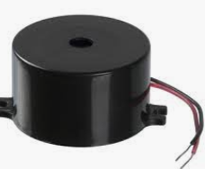

3.2 SOFTWARE COMPONENT - The Arduino IDE software is known that Arduino IDE is open source software. This software is used to compile the program into the microcontroller. It uses C-programming language for coding. There is two parts in this code mainly, one is Void setup () which is known as preparation for the program and it runs only once and another one is void loop () which is known as execution for the program. In this software we have used some function from the Arduino library to operate servo motors, LCD Display, sensors and LED’s for the detection of the availability of the parking slot.

**4. THE DESIGN OF THE SMART PARKING SYSTEM**

*Prototype Mechanism is* *well described by following flowchart:*

No entry, all parking slots are full

Is slot available?

Green LED

Blue LED

Red LED

Is dist. < 10?

Is dist. < 20?

LCD Display connected with the Arduino update the information of slot availability

Enter parking area and check the and move towards green led slot

IR sensor GPD21 detects the vacant slot and distance of the vehicle

Gate operated by servo motor opens as the vehicle approaches near to the vacant slot.

Updates the slots

No

Yes

No Yes

Yes

Flowchart for working process of prototype

Hardware Connections - The hardware connection of the implemented circuit is shown in the fig.1.

* Connect the Vcc stick to the positive rail on breadboard and Gnd stick to the negative rail on breadboard.
* Connect the two Sharp-IR sensors (GP2D21) positive and negative to pins A1, A0 of Arduino, respectively.
* Connect red, blue and green LEDs to both sensors to positive rail of the bread board and 3,4,5,6,7 and 8 pins of Arduino.
* Connect LCD, Vcc to positive and gnd to negative rail on the breadboard.
* Connect servo motor to positive and negative rail of the bread board and A3, A4 pins of the Arduino respectively.

4.1 THE WORKING PROCEDURE OF THE PROTOTYPE

The working procedure of the different components of the prototype is as follows:

*LCD Display*:

Available slots = x

Occupied slots = y

X= total number of green led lights

Y= total number of red led lights

Here I assigned each green LED’s with variable like G1, G2... so on

If any green LED is on/high, then the value assigned to that led is 1 anf if the LED is low then the value assigned is 0.

Then x= G1+G2+G3+…

Here the project demonstrates only two parking slots then

x= G1+G2

Similarly, each red LED’s with variable like R1, R2... so on.

If any red LED is on/high, then the value assigned to that led is 1 and if the LED is low then the value assigned is 0.

Then x= R1+R2+R3+…

Here the project demonstrates only two parking slots then

y= R1+R2

Is R1=high,

Is R2= high

R2

no yes

Output

R1=1 and R2=1

Output

R1=0 and R2=0

Output

G1=1 and G2=1

Is G1=high, G2=high

no yes

Output

G1=0 and G2=0

X= G1+G2

Y=R1+R2

Display x= availability slots, y= occupied slots

Flowchart - LCD operation

SHARP IR – SENSOR GP2D12*:* The working description of the sensor is shown below flowchart.

void loop()

{

Irval = analogRead(Ir input value); // reads the value of the sharp sensor

distance = (6787.0/(Ir1val - 3.0)) -4.0;

Serial.print(Distance):

}

start

Vehicle enter the parking area and approaches the nearest slot indicated by green led

If distance is >40 cm

yes

Green led glow as the indication of vacant slot and available to be parked

As the vehicle approaches the parking slot and distance at 30 cm the gate opens which is operated by servo motor

Is distance < 20cm

Is distance =<30 cm

no

yes yes

Warning buzzer and blue led light will glow as Moving close to wall till it moves the vehicle moves back certain distance

The slot is not vacan t and red Led will glow

Flowchart - describes the operation in parking slot with the use of sensors, buzzers and leds.

4.2 CIRCUIT DIAGRAM:

The hardware connection of the implemented circuit is represented below:

Figure The circuit diagram of prototype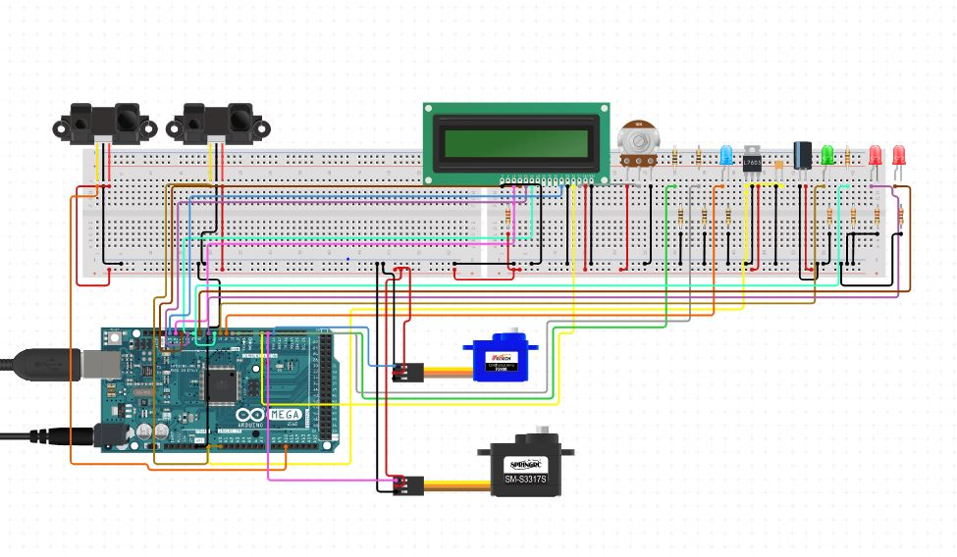

4.3 IMPLENTATION OF THE PROJECT PROTOTYPE:

The working prototype that has implemented in this project in this shown below by images:

When (Ir1) sensor in right detects the object, which is approx. 10 cm of the distance red led light glows indication an object is there or as vehicle occupied the slot and servo motor operated. As the object is too close to the sensor it represents the caution by blue led and buzzer to alert the driver from dangers shown in below in figure10.

Similarly, the sensor in the left (Ir2) detects no obstacle or object within its range so it represents the empty slot by green led light as no vehicle/ object is in front of it as shown below in figure 10.

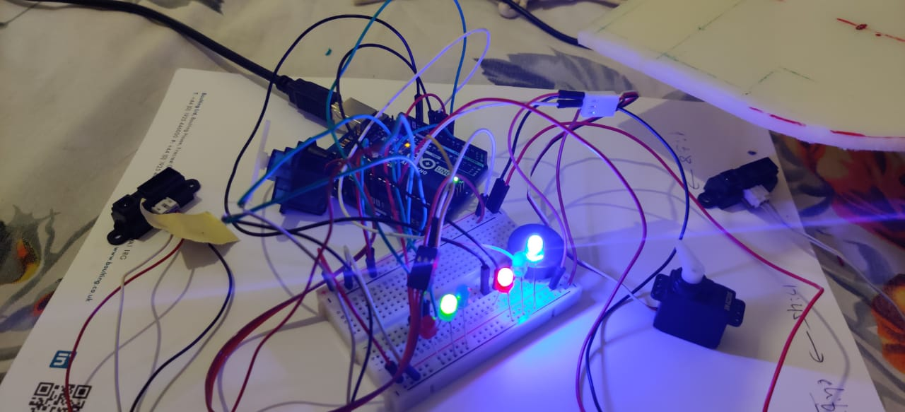

Figure - Demo-1

While capturing the image of this circuit connection the sensor at the left in the figure 11 sensed or detects my phone and changed its color from green led to red led light by this the range determination is also successfully tested.

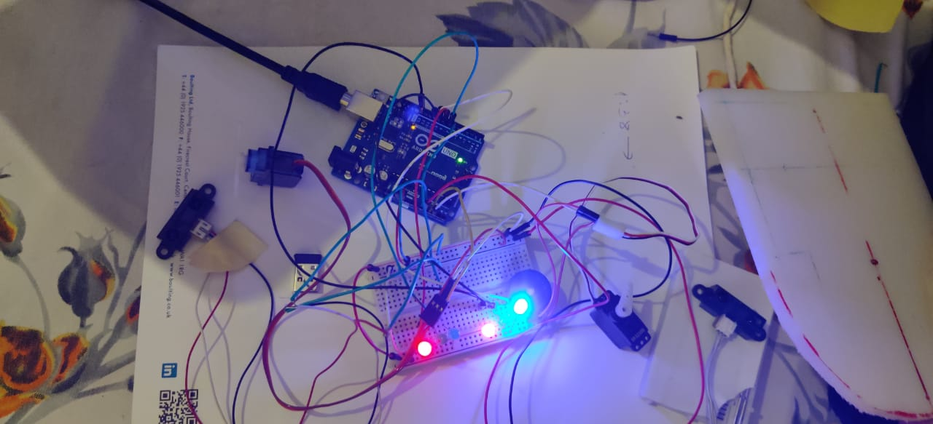

Figure – Demo-2

The output result which is obtained from the both distance measuring sensor is shown in figure12.

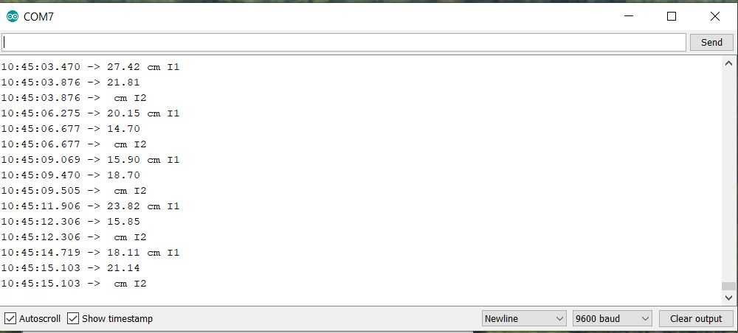

Figure Output results of the distance measuring sensor

4.4 ADVANTAGES:

* Traffic congestion decreases.
* Pollution is reduced.
* Hunting for parking spaces is reduced.
* Best possible use of available space.
* Less time spent on parking results in more time to use your services.
* Traffic flow improves, saving time and increasing safety.
* Easy identification of the available parking slot.
* Alerts the driver from being approaching too close to wall before.

1. **CONCLUSION**

After doing this project I conclude that, it is very simple to develop and install. It is the cost effective and DIY to everyone and by implementing this we can easily identify the availability of the parking slot in that area without entering that area by display which saves time, fuel and energy. If this can be implemented to each possibility areas, then there will be reduction in the traffic jam problems and increases the safety of the vehicle when parked into the parked area compared to the sideroad. This smart parking system can implement in one’s home garage/vehicle parking area also.

1. **FUTURE WORK**
2. The performance the developed project can be improved by upgrading the sensor GP2D12 to GP2YA021Yk0f. (2020)
3. By adding the component Bluetooth interfacing between LCD and Arduino controller we can reduce the wired connections between them and can make the system less complex.
4. In this system by the counter that is calculation of the time implementation we can know for how long time the vehicle is parked slot which can increased its applications such it is used in parking payment etc.
5. By adding the speed tracker sensor system so that in parking system the vehicle should move in certain limit speed if the speed exceeds the gate will close automatically this is most crucial one and while entering or whole exit of the parking large number of accidents have been recorded so this accident can be minimized by implementation of the speed limit.
6. **BIBLOGRAPHY**

Weingärtner, I. and Elster, C., 2004. System of four distance sensors for high-accuracy measurement of topography. Precision Engineering, 28(2), pp.164-170.

Hartt, C., 2020. Parking Today | Articles - On Street Parking Issues In India. [online] Parkingtoday.com. Available at: <https://www.parkingtoday.com/articledetails.php?id=2547&t=on-street-parking-issues-in-india> [Accessed 22 March 2020].

Engineering.purdue.edu. 2020. [online] Available at: <https://engineering.purdue.edu/ME588/SpecSheets/sharp_gp2d12.pdf> [Accessed 24 March 2020].

Components101.com. 2020. 16X2 LCD Module: Pinout, Diagrams, Description & Datasheet. [online] Available at: <https://components101.com/16x2-lcd-pinout-datasheet> [Accessed 26 March 2020].

Sparkfun.com. 2020. [online] Available at: <https://www.sparkfun.com/datasheets/Sensors/Infrared/gp2y0a02yk_e.pdf> [Accessed 26 March 2020].

Circuitdigest.com. 2020. Servo Motor Basics, Working Principle & Theory. [online] Available at: <https://circuitdigest.com/article/servo-motor-basics> [Accessed 26 March 2020].